**Minimizing Costs on AWS Platform**

Another critical aspect is the careful selection of Instance Types and Sizes based on specific workload requirements. This tailored approach ensures that resources are optimized for both performance and cost-effectiveness. By aligning instances with the unique demands of applications and services, ASU Inc. avoids overprovisioning and, consequently, unnecessary costs.

AWS offers a diverse range of storage classes, including Standard, Infrequent Access, and Glacier. This variety allows ASU Inc. to align storage costs with the actual access frequency of data. Frequently accessed data can be stored in Standard storage for quick retrieval, while less frequently accessed data can be transitioned to more cost-efficient storage classes like Infrequent Access or Glacier.

Furthermore, the implementation of auto-scaling mechanisms is crucial for handling dynamic workloads. By automatically adjusting the number of instances based on demand fluctuations, auto-scaling ensures that resources are efficiently utilized. During peak demand periods, additional resources are provisioned to maintain optimal performance, while during off-peak periods, the infrastructure scales down, preventing unnecessary costs.

In essence, ASU Inc. can achieve a well-rounded cost-minimization strategy on the AWS platform by combining Reserved Instances, thoughtful instance sizing, strategic storage class utilization, and the dynamic resource allocation facilitated by auto-scaling. This holistic approach allows the organization to maximize the value of its cloud investment while minimizing unnecessary expenditure.

# Process for Migrating to AWS

Migrating from an internal infrastructure to AWS is a complex yet vital undertaking that requires a well-structured and phased approach. The success of this migration relies on careful planning, strategic decision-making, and thorough execution. The following comprehensive guide outlines the key steps involved in the migration process for ASU Inc.

1. Assessment and Planning:

The initial phase involves a detailed analysis of ASU Inc.'s current infrastructure, dependencies, and data. This includes an evaluation of existing applications and services. Leveraging the AWS Migration Hub facilitates centralized tracking, providing a holistic view of the migration progress.

2. Designing the Architecture:

Plan the AWS architecture meticulously to ensure a seamless transition. This involves defining the Virtual Private Cloud (VPC), subnets, security groups, and identity and access management (IAM) roles. Strategies for data migration and backup are essential components of the architectural design.

3. Migration of Servers:

Utilize AWS Server Migration Service (SMS) or AWS Database Migration Service (DMS) for the migration of servers and databases. Creating Amazon Machine Images (AMIs) streamlines server replication, ensuring consistency and efficiency in the migration process.

4. Data Migration:

Execute data migration using AWS Snowball for large-scale transfers and AWS DataSync for continuous data synchronization between on-premises and AWS. These services offer robust solutions for overcoming data transfer challenges, ensuring the integrity and security of the information being migrated.

5. Testing and Validation:

Conduct thorough testing in the AWS environment to validate the functionality, performance, and security of applications and services. This phase is crucial for identifying and resolving any issues that may arise during the migration, ensuring a smooth transition for end-users.

6. Optimization:

Optimize resource allocation by leveraging cost management tools and implementing best practices. AWS Trusted Advisor provides valuable recommendations for cost optimization, ensuring that ASU Inc. maximizes the efficiency of its cloud resources.

7. Training and Documentation:

Train staff on AWS services to ensure a smooth transition and ongoing operational success. Comprehensive documentation of the new architecture, processes, and best practices is essential for knowledge transfer and maintaining operational continuity.

**Security Group configuration**:

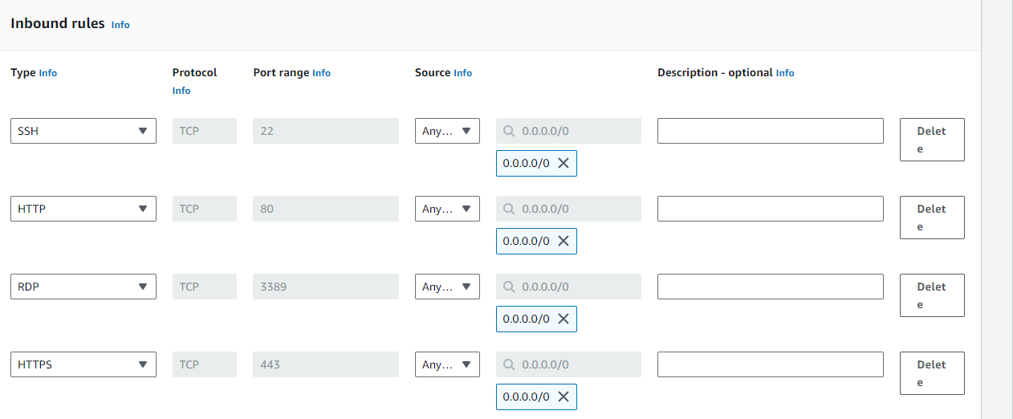

**Windows Instances and IIS Installation.**

Running Instances:

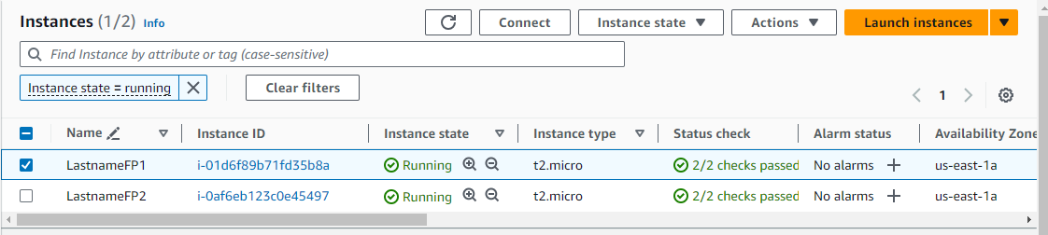

**IIS Installation:** 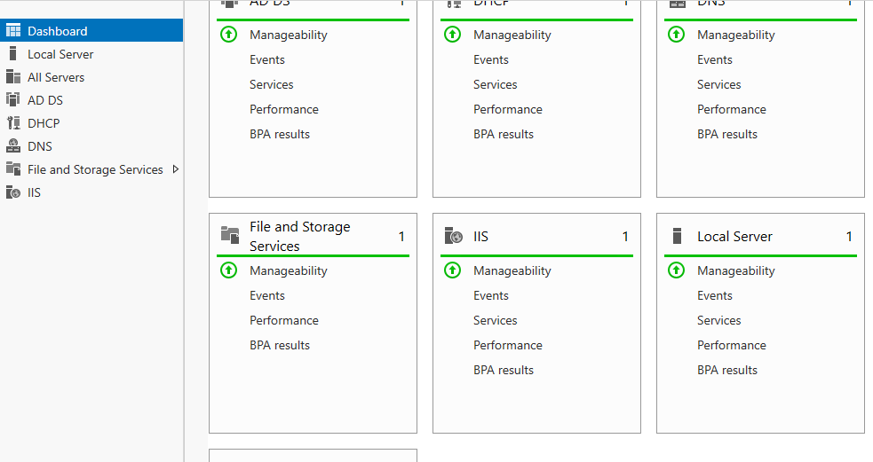

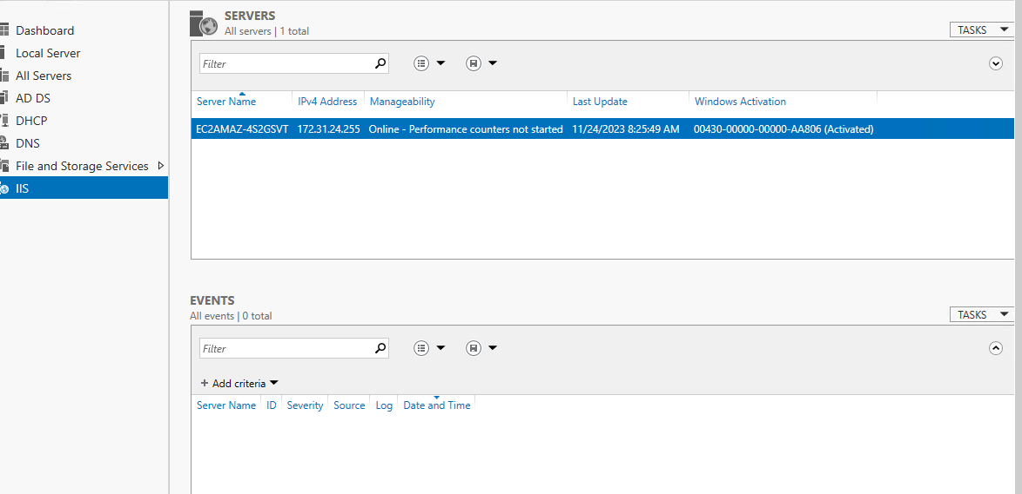

Created an index page:

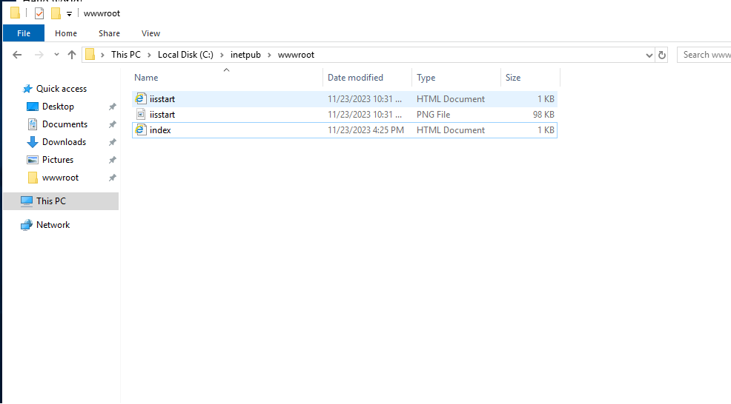

It works:

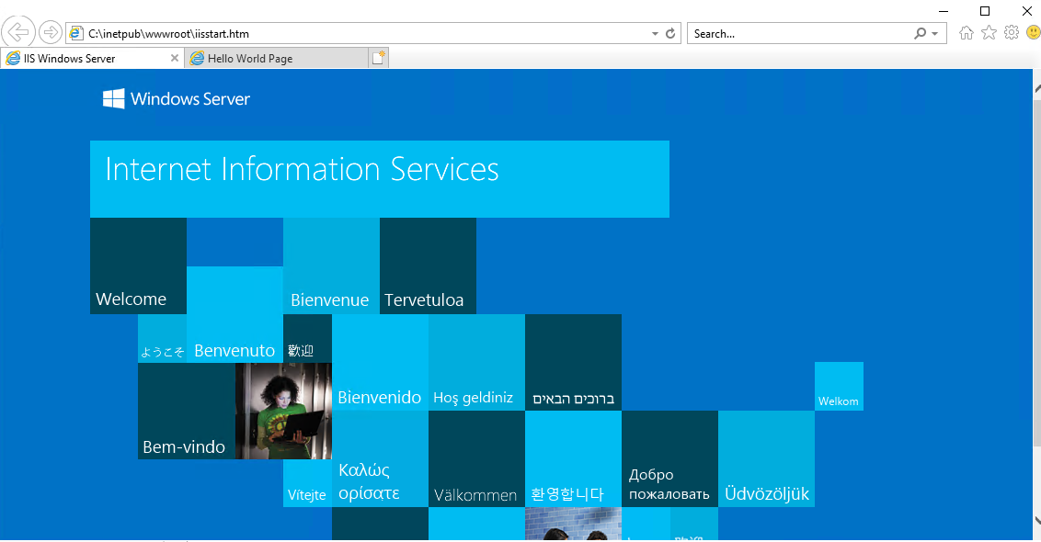

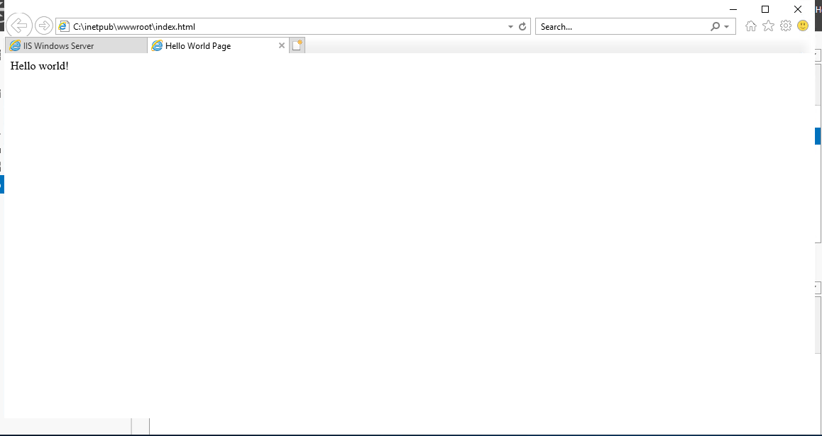

Load Balancer:

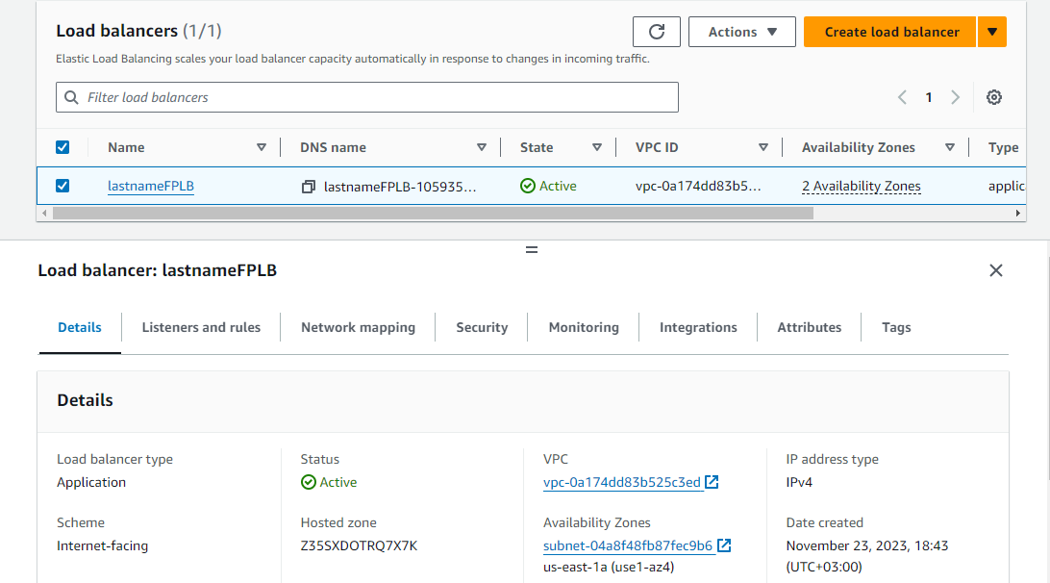

Target Groups:

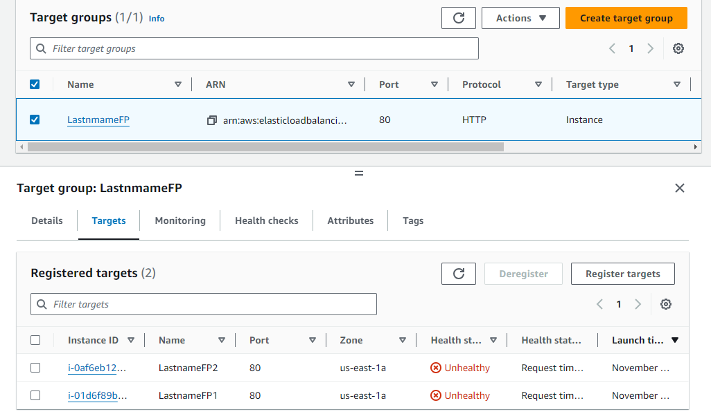

**Route 53 DNS Entry:**

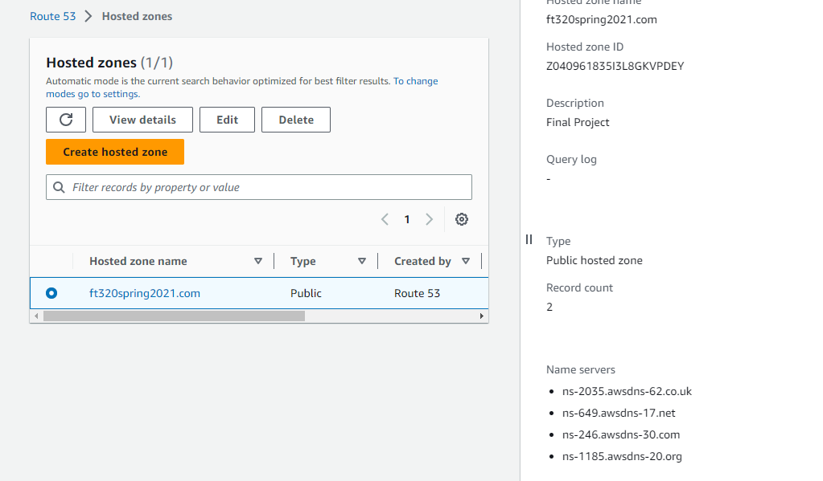

**CloudWatch Metrics:**

